

**Manav Rachna International Institute of Research and Studies**

**School of Computer Applications**

**Department of Computer Applications**

|  |  |
| --- | --- |
| **Submitted By** | |
| **Student Name** | **Monika Sharma** |
| **Roll No** | **24/SCA/BCA(AI&ML)/041** |
| **Programme** | **Bachelor of Computer Applications** |
| **Semester** | **1st** |
| **Section/Group** | **B** |
| **Department** | **Computer Applications** |
| **Session / Batch** | **2024-27** |
|  | |
| **Submitted To** | |
| **Faculty Name** | **Dr. Sakshi Gupta** |

|  |  |  |  |  |
| --- | --- | --- | --- | --- |
| **Index** | | | | |
| **S. No.** | **Program Date** | **Program** | **Signature/Date** | **Grade** |
| **1.** |  | Create a simple html using basic tags. |  |  |
| **2.** |  | Create web page that displays your name to the screen. |  |  |
| **3.** |  | Create a web page and show the output from 1 to 10 in separate lines. |  |  |
| **4.** |  | Create a web page and show the output from 1 to 10 in separate lines, each number being in different color. |  |  |
| **5.** |  | How do I make a picture as a background on my web pages? |  |  |
| **6.** |  | Create a web page to print a paragraph with 4-5 sentences, each sentence shall have a different font. |  |  |
| **7.** |  | Write HTML code to print a paragraph that is description of a book, it shall include the title of the book, its author name; name and title should be underlined and all adjectives shall be bold and Italics. |  |  |
| **8.** |  | Write HTML code to print your name using Heading tag, every letter shall be of different heading size. |  |  |
| **9.** |  | Write HTML code to print the sequence of numbers 1-20. Each number shall be in different line with number 2 next to it as subscript, an equal sign and the result. |  |  |
| **10.** |  | Write HTML code to display an image with border of size with width 200, height 200 pixels, leaving Hspace and Vspace of your choice with image hanging in the right side on the screen |  |  |
| **11.** |  | Write HTML code to create a web page with heading. The heading shall be displayed at the top-center of the page and the image shall be at the centre, just below the heading. |  |  |
| **12.** |  | Write HTML code using Multimedia tags. |  |  |
| **13.** |  | Create a Table using Rowspan and Colspan taking example of student Record. |  |  |
| **14** |  | Write HTML code using table tag <table> and cellpadding and cell spacing as its attributes. |  |  |
| **15** |  | Create unordered, ordered and definition Lists taking example of your subjects in MCA IST, IInd and IIIrd Semester. |  |  |
| **16** |  | Write HTML code using <frameset> and <frame> tag with all its attributes |  |  |
| **17** |  | Write HTML code to design a form in HTML using controls and buttons such as Textbox, Text area, password, submit button, browse button, drop-down menu |  |  |
| **18** |  | Write HTML code to design a Registration Form in HTML. |  |  |
| **19** |  | Write HTML code to design a student admission Form in HTML. |  |  |
| **20** |  | Create a proper home page of your own using any components and styles. |  |  |
| **21** |  | Write HTML code for including Local hyperlinking in a web page. |  |  |
| **22** |  | Write HTML code for including Inter hyperlinking in a web page. |  |  |
| **23** |  | Write HTML code for including External hyperlinking in a web page. |  |  |
| **24** |  | Write code to show External CSS with HTML code |  |  |
| **25** |  | Write code to show Internal CSS with HTML code. |  |  |
| **26** |  | Write code to show Inline CSS with HTML code. |  |  |

|  |  |  |  |  |  |
| --- | --- | --- | --- | --- | --- |
| **27** |  | Write a program to add two numbers using form in JavaScript. |  |  |  |
| **28** |  | Write a program in JavaScript to swap two images using on mouseover event. |  |  |  |
| **29** |  | Write a simple JavaScript program to sort an array |  |  |  |
| **30** |  | Write a JavaScript program to take as input three numbers from the user. Find the minimum and maximum of the three numbers. Print the following output in BOLD in the following format: |  |  |  |

Q1= **Create a simple html tag using basic tags?**

<HTML>

<HEAD>

<TITLE> HELLO WORLD </TITLE>

</HEAD>

<body>

<H1> HELLO WORLD </h1>

</Body>

</html>

Output:



Q2= **Create a web page that displays your name to the screen?**

Ans=<HTML>

<HEAD>

<body>

<H1> Monika Sharma </h1>

</body>

</html>

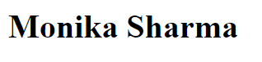 = output

**Q3= Create a web page and show the output from 1 to 10 in separate lines?**

<HTML>

<HEAD>

<TITLE> HELLO WORLD </TITLE>

</HEAD>

<body>

1<br> 2<br> 3<br> 4<br> 5<br> 6<br> 7<br> 8<br> 9<br> 10<br>

</body>

</html>

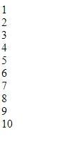 **=OUTPUT**

**Q4= Create a webpage and show the output from 1 to 10 in separate lines, each number being in different color?**

<HTML>

<HEAD>

<TITLE> HELLO WORLD </TITLE>

</HEAD>

<body>

<font color="blue"> 1 </font><br>

<font color="red"> 2 </font><br>

<font color="yellow"> 3 </font><br>

<font color="black"> 4 </font><br>

<font color="brown"> 5 </font><br>

<font color="pink"> 6 </font><br>

<font color="orange"> 7 </font><br>

<font color="purple"> 8 </font><br>

<font color="grey"> 9 </font><br>

<font color="green"> 10 </font><br>

</body>

</html>

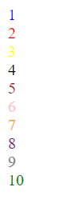  **=OUTPUT**

**Q5= how to make a picture as a background on my web pages?**

ANS= <HTML>

<HEAD>

<TITLE> HELLO WORLD </TITLE>

</HEAD>

<body>

<body background="C:\Users\Monika\Downloads/monika.jpg">

</body>

</html>

OUTPUT:



**Q6=Create a web page to print a paragraph with 4-5 sentences, each sentences shall have a different font?**

**Ans:**

<html>

<body>

<h1>Introduction</h1>

<P>

<B>My name is Monika Sharma. </B><br>

<I>I am Currently studying in manav rachna international institute of research and science. It is situated in

Badkhal, Faridabad. </I>

<br> <U> My course that i am pursuing right now is BCA(AI/ML) </U>.

<br><B> My Hobbies are playing games and watching movies and series.</B><br>

</p>

</body>

</html>

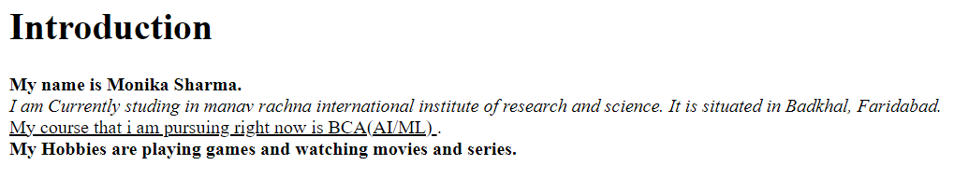

**= OUTPUT**

**Q7=write HTML code to print a paragraph that is described of a book, it shall include the title should be underlined and all adjectives shall be bold and italics?**

<HTML>

<Body>

<H1><u><b><font color="red"> Title of The Book:The Great Gatsby</font></b></u></H1>

<p><b> Author Name:F. Scott Fitzgerald </b><br>

<i>In spring 1922, Nick Carraway—a Yale alumnus from the Midwest and a World War I veteran—journeys to New York City to obtain employment as a bond salesman. He rents a bungalow in the Long Island village of West Egg, next to a luxurious estate inhabited by Jay Gatsby, an enigmatic multi-millionaire who hosts dazzling soirées yet does not partake in them.

One evening, Nick dines with a distant cousin, Daisy Buchanan, in the old money town of East Egg. Daisy is married to Tom Buchanan, formerly a Yale football star whom Nick knew during his college days. The couple has recently relocated from Chicago to a mansion directly across the bay from Gatsby's estate. There, Nick encounters Jordan Baker, an insolent flapper and golf champion who is a childhood friend of Daisy's. Jordan confides to Nick that Tom keeps a mistress, Myrtle Wilson, who brazenly telephones him at his home and who lives in the "valley of ashes", a sprawling refuse dump.[33] That evening, Nick sees Gatsby standing alone on his lawn, staring at a green light across the bay.</i></P>

</p></body></html>

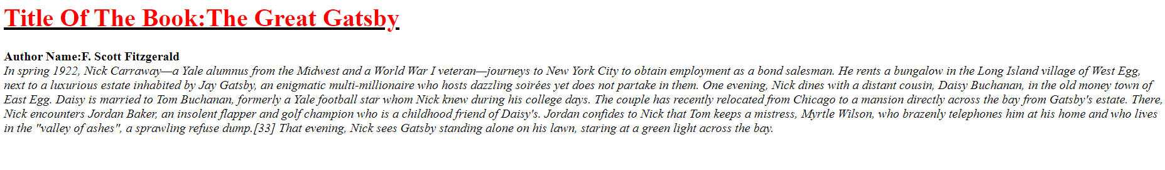

**Q8: Write HTML code to print your name using heading tag, every letter shall be of different heading size?**

**<HTML>**

**<BODY>**

**<H1> M</h1>**

**<H2> O</h2>**

**<H3> N</h3>**

**<H4> I</h4>**

**<H5> K</h5>**

**<H6> A</h6><br>**

**<H1> S</h1>**

**<H2> H</h2>**

**<H3> A</h3>**

**<H4> R</h4>**

**<H5> M</h5>**

**<H6> A</h6><br>**

**</body>**

**</html>**

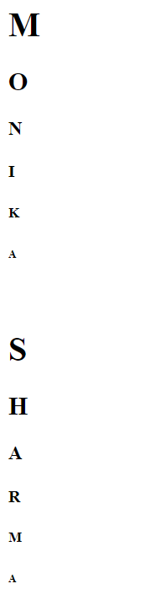 = OUTPUT

**Q9: Write Html code to print the sequence of number 1-20. each no shall be in different line with number 2 next to it as subscript, an equal sign and the result?**

**Ans:** <html>

<head>

<title>Number Sequence</title>

</head>

<body>

<p>1<sub>2</sub> = 1</p>

<p>2<sub>2</sub> = 4</p>

<p>3<sub>2</sub> = 9</p> <p>4<sub>2</sub> = 16</p> <p>5<sub>2</sub> = 25</p> <p>6<sub>2</sub> = 36</p> <p>7<sub>2</sub> = 49</p> <p>8<sub>2</sub> = 64</p> <p>9<sub>2</sub> = 81</p>

<p>10<sub>2</sub> = 100</p> <p>11<sub>2</sub> = 121</p> <p>12<sub>2</sub> = 144</p> <p>13<sub>2</sub> = 169</p> <p>14<sub>2</sub> = 196</p> <p>15<sub>2</sub> = 225</p> <p>16<sub>2</sub> = 256</p> <p>17<sub>2</sub> = 289</p> <p>18<sub>2</sub> = 324</p> <p>19<sub>2</sub> = 361</p> <p>20<sub>2</sub> = 400</p> </body>

</html>

Output:

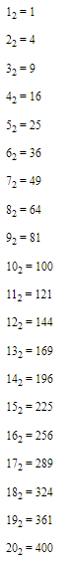

Q10. wtrite an html code to display an image with border of size with width 200 height 200 pixels, leaving Hspace and Vspace of your choice with image hanging in the right side on the screen.

Ans: <HTML>

<head>

<title>Image Display</title>

<style>

img {

border: 2px solid black;

width: 250px;

height: 250px;

display: block;

margin-left: auto;

margin-right: 0;

margin-top: 20px;

margin-bottom: 20px; }

</style>

</head>

<body>

<img src="C:\Users\Monika\Downloads/monika.jpg" alt="Sample Image">

</body>

</html>

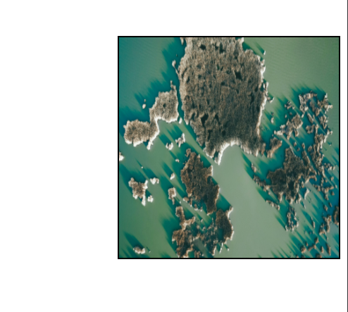

Q11: write a html code to create a web page with heading. the heading shall be displayed at the top-centre of the page and the image shall be at the centre, just below the heading.

Ans: <html>

<body>

<center>

<h1>The Island</h1>

<img src="C:\Users\Monika\Downloads/monika.jpg” alt="scenery" height="450" width=”450” >

</center>

</body>

</html>

Output:

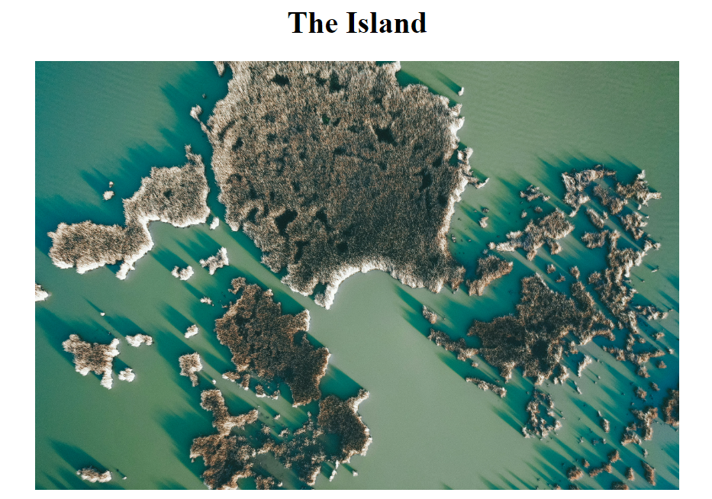

Q12. Write HTML code using Multimedia tags.

<html>

<body> <center>

<h1> multimedia tags: </h1>

<h1>img</h1>

<img src="C:\Users\Monika\Downloads/monika.jpg" alt="scenery" height="450" width="450"/>

<h1> audio </h1>

<audio src="C:\Users\Monika\Downloads/Music.mp3" controls/>

<center> </body>

</html>

Output:

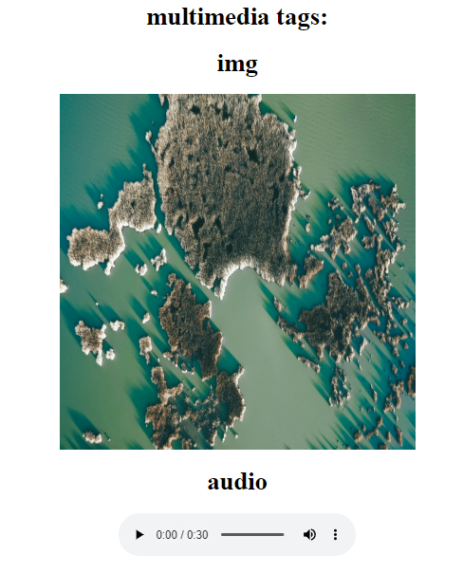

**Video tag:**

**<html>**

**<body>**

**<video src="C:\Users\Monika\Downloads/vidio.mp4" width="720" heigth="480" alt="vidio" controls="control">**

**</video>**

**</body>**

**</html>**

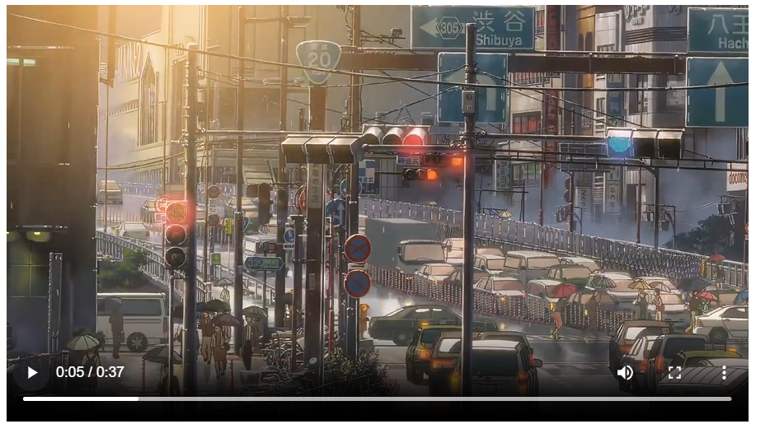

**Q13:** **Create a Table using Rowspan and Colspan taking example of student Record?**

**Ans:**

1. **rowspan**

<html>

<body>

<h1> table </h1>

<table border="1">

<tr>

<th> name</td>

<th> Class</td>

</tr>

<tr>

<td >Monika</td>

<td rowspan="2">1B</td>

</tr>

<tr>

<td> Sanya</td>

</tr>

</table>

</body>

</html>

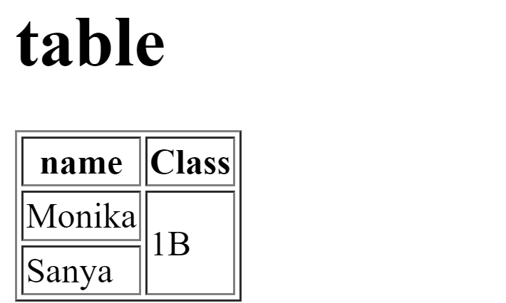

2.Colspan:

<html>

<body>

<h1> table </h1>

<table border="1">

<tr>

<th> name</td>

<th> roll no</td>

<th> class</th>

</tr>

<tr>

<td >Monika</td>

<td colspan="2">41</td>

</tr>

<tr>

<td> Sanya</td>

<td> 60</td>

<td> bca </td>

</tr>

</table>

</body>

</html>

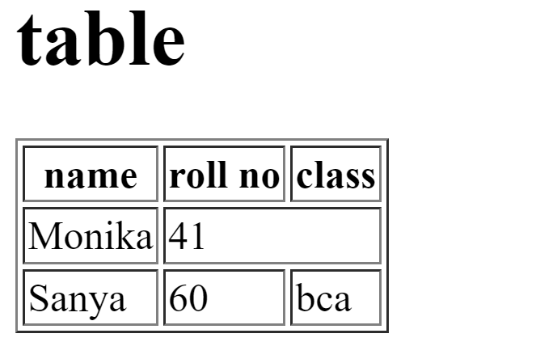

**Q14: Write HTML code using table tag <table> and cellpadding and cellspacing as its attributes**?

<html>

<head>

<style>

table, th, td {

padding : 15;

Spacing : 15;

}

</style>

</head>

<body>

<table border="1">

<tr>

<th> Name </th>

<th> Class </th>

<th> Roll No. </th>

</tr>

<tr>

<td> Monika</td>

<td> 1B </td>

<td> 41 </td>

</tr>

<tr>

<td> Sanya </td>

<td> 1B </td>

<td> 60 </td>

</tr></table>

</body>

</html>

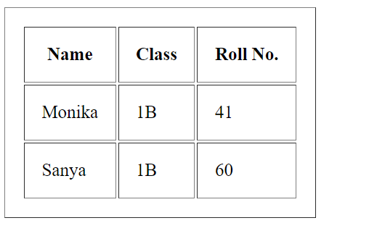

Q15: Create unordered, ordered and definition Lists taking example of your subjects in MCA IST, IInd and IIIrd Semester?

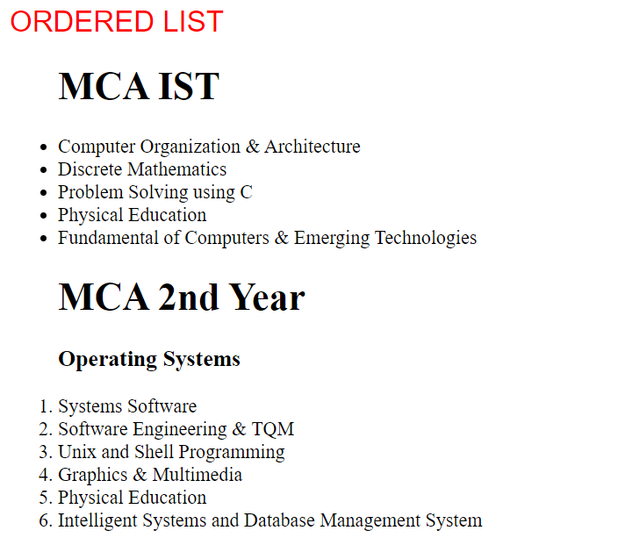

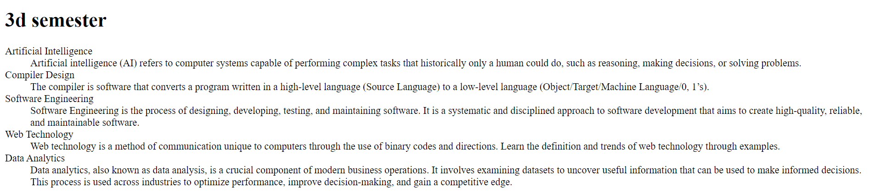

Q17: Write HTML code to design a form in HTML using controls and buttons such as Textbox, Text area, password, submit button, browse button, drop-down menu?

Ans: <html>

<body>

<h1> FORM </h1>

<fieldset>

<label for="name">Name:</label>

<input type="text" id="name" name="name" required/>

<br><br>

<label for="name">Name:</label>

<input type="text" id="name" name="name" required/>

<br><br>

<label for="Password">Password:</label>

<input type="Password" id="Password" name="Password" required/>

<br><br>

<label for=”file">File</label>

<input type="file" id=" file " name=" file " required/>

<br><br>

<h3> text area</h3>

<textarea cols="50" rows="5"/></textarea><br><br>

<button type="submit">Submit</button>

<button type="reset">Reset</button><br><br>

<select id="subjects" name="subjects">

<option value="wt" id="subjects" name="subjects">wt</option>

<option value="Dbms" id="subjects" name="subjects">Dbms</option>

<option value="ITPC" id="subjects" name="subjects">ITPC</option>

</select>

</fieldset>

</form>

</body>

</html>

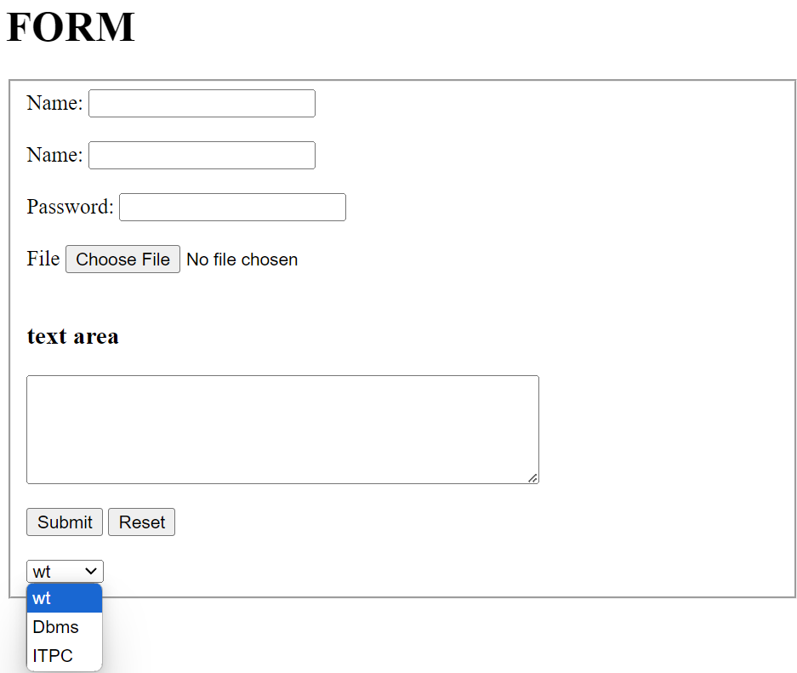

Q18: Write HTML code to design a Registration Form in HTML?

Ans: <html>

<head>

<title> Form </title>

</head>

<body>

<h1>FORM</h1>

<form>

<fieldset>

<legend><b>REGISTRATION FORM</b></legend>

<label for="fname" id=name><b>Name:</label><br>

<input type="text" required>

<label for="12th Marks" id="name"><b> 12th Marks (%): </b></label>

<input type="number" max="100" min="33" required/>

<b> Upload here</b>

<input type="file"/><br>

<label for="Email" id=name required>Email:</label><br>

<input type="Email"/>

<label for="10th Marks" id="name" required ><b>10th Marks (%): </b></label>

<input type="number" max="100" min="33"/>

<b> Upload here</b>

<input type="file" name="mark sheet"/><br>

<label for="Name" id=name>Father's Name:</label><br>

<input type="text"/>

<font color="red">Character certificate</font>

<input type="file" required/><br>

<label for="Course Name" id=name>Course Name:</label><br>

<input type="text"/>

<font color="red">Migration certificate</font>

<input type="file"/><br><br>

<b>Phone No:</b>

<input type="text" size="9" maxlength="10" required/>

<b><u> gender</u></b><br>

<input type="radio" name="gender"/>

<label for="gender" name="gender">Male</label>

<input type="radio" name="gender"/>

<label for="gender" name="gender">female</label>

<input type="radio" name="gender"/>

<label for="gender" name="gender">others</label><br>

<b><u>Subject</u></b><br>

<input type="Checkbox"/>

<label for="Subject" name="subject">Wt</label>

<input type="Checkbox"/>

<label for="Subject" name="subject">Dbms</label>

<input type="Checkbox"/>

<label for="Subject" name="subject">ITPC</label>

<input type="Checkbox"/>

<label for="Subject" name="subject">Eng</label>

<input type="Checkbox"/>

<label for="Subject" name="subject">History</label><br>

<lable for="date" name="birth">DOB:</lable>

<input type="date" max="2007" min="2003" required/><br><br>

<lable for="date" name="birth">Date of joining</lable>

<input type="month" id="joining" required/><br>

<br>

<button>Submit</button>

</fieldset>

</form>

</body>

</html>

OUTPUT:

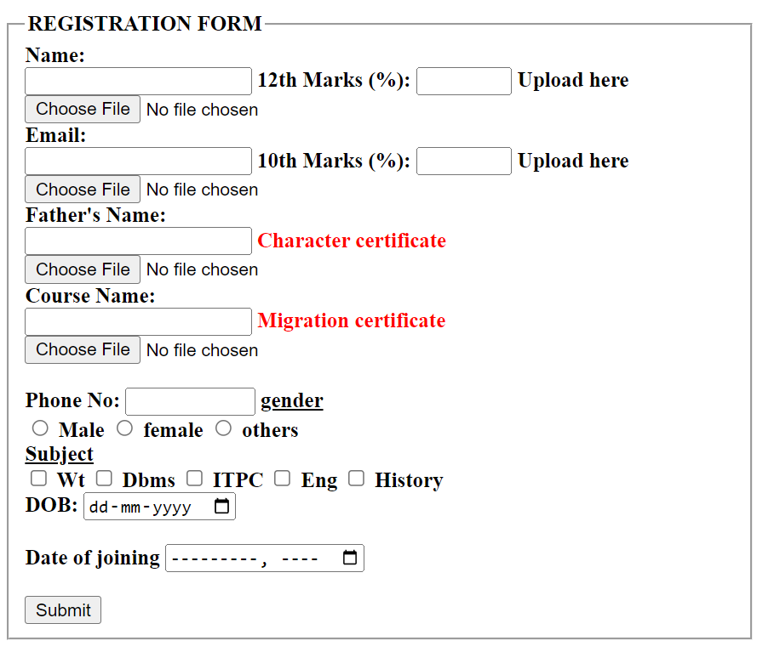

Q19. Write HTML code to design a student admission Form in HTML?

Ans: <html>

<head>

<title> Form </title>

</head>

<body>

<h1>FORM</h1>

<form>

<fieldset>

<legend><b>ADDMISSION FORM</b></legend>

<label for="fname" id=name><b>Name:</label><br>

<input type="text" required>

<label for="12th Marks" id="name"><b> 12th Marks (%): </b></label>

<input type="number" max="100" min="33" required/>

<b> Upload here</b>

<input type="file"/><br>

<label for="Email" id=name required>Email:</label><br>

<input type="Email"/>

<label for="10th Marks" id="name" required ><b>10th Marks (%): </b></label>

<input type="number" max="100" min="33"/>

<b> Upload here</b>

<input type="file" name="mark sheet"/><br>

<label for="Name" id=name>Father's Name:</label><br>

<input type="text"/>

<font color="red">Character certificate</font>

<input type="file" required/><br>

<label for="Course Name" id=name>Course Name:</label><br>

<input type="text"/>

<font color="red">Migration certificate</font>

<input type="file"/><br><br>

<b>Phone No:</b>

<input type="text" size="9" maxlength="10" required/>

<b><u> gender</u></b><br>

<input type="radio" name="gender"/>

<label for="gender" name="gender">Male</label>

<input type="radio" name="gender"/>

<label for="gender" name="gender">female</label>

<input type="radio" name="gender"/>

<label for="gender" name="gender">others</label><br>

<b><u>Subject</u></b><br>

<input type="Checkbox"/>

<label for="Subject" name="subject">Wt</label>

<input type="Checkbox"/>

<label for="Subject" name="subject">Dbms</label>

<input type="Checkbox"/>

<label for="Subject" name="subject">ITPC</label>

<input type="Checkbox"/>

<label for="Subject" name="subject">Eng</label>

<input type="Checkbox"/>

<label for="Subject" name="subject">History</label><br>

<lable for="date" name="birth">DOB:</lable>

<input type="date" max="2007" min="2003" required/><br><br>

<br>

<button>Submit</button>

</fieldset>

</form>

</body>

</html>

OUTPUT:

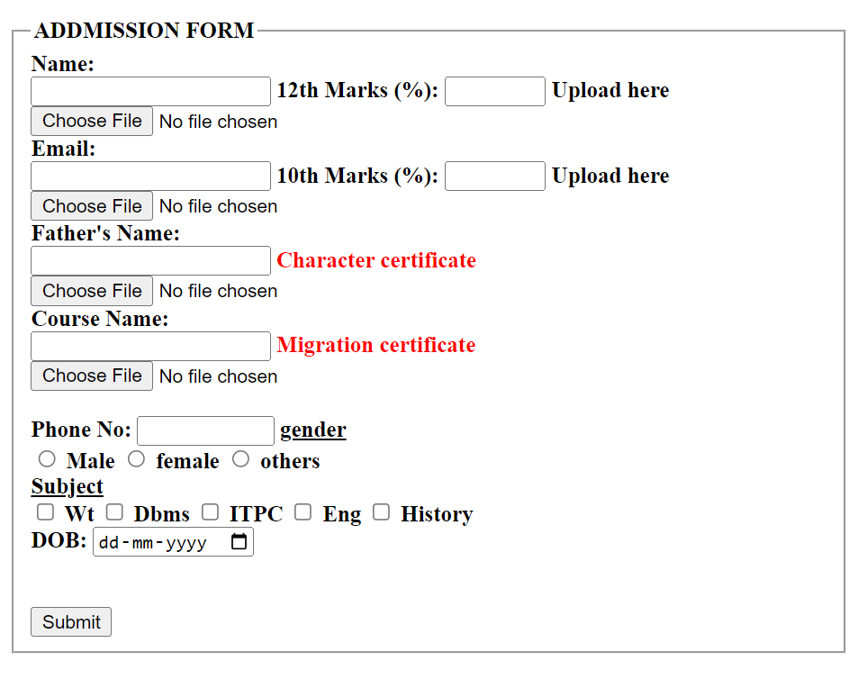

Q20: Create a proper home page of your own using any components and styles?

Ans <html>

<head>

<style>

/* different styles of heading */

H1, h2, h3 {

text-align: center;

color: Red;

}

#para1 {

text-align: center;

color: Blue;

font-size:15;

}

.center{text-align: center;

color: Green;

font-size:25;

font-family: sans-serif;

}

</style>

</head>

<body bgcolor="blue">

<H1>Software application</h1>

<h2> Efficient,Work Better,Cheap </h2>

<p class="center"> try software applications in your pc</p>

<hr>

</body>

</html>

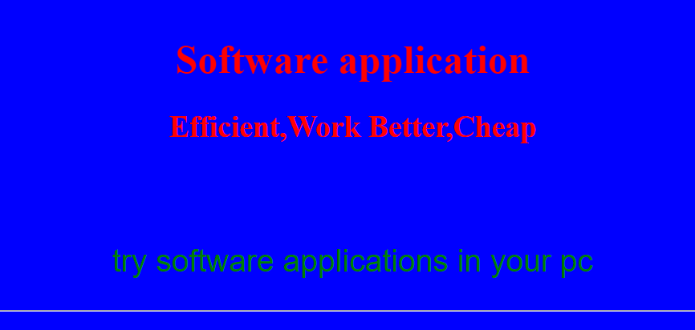

**Q21. Write HTML code for including Local hyperlinking in a web page.**

Input:

<html>

<body>

<h1>Local Hyperlinking</h1>

<p>HTML code for including Local hyperlinking in a web page.</p>

<a href="#monika">Jump to page 2</a>

<h2 id="monika">Section 2</h2>

<p>This is the page 2.</p>

</body>

</html>

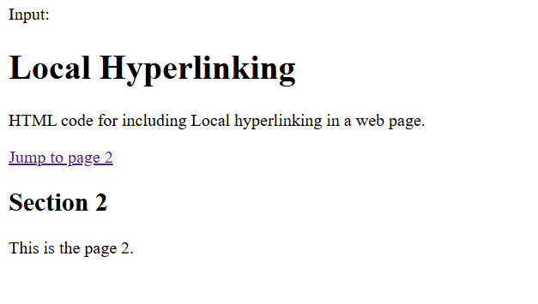

**Q22. Write HTML code for including Inter hyperlinking in a web page.**

<html>

<body>

<h1>Inter Hyperlinking</h1>

<p>This is a sample paragraph. </p>

<a href="page2.html">Go to Page 2</a>

</body>

</html>



**Q23. Write HTML code for including External hyperlinking in a web page?**

<html>

<body>

<h1>External Hyperlinking</h1>

<p>This is a sample paragraph.</p>

<a href="https://www.example.com">Visit Example Website</a>

</body>

</html>

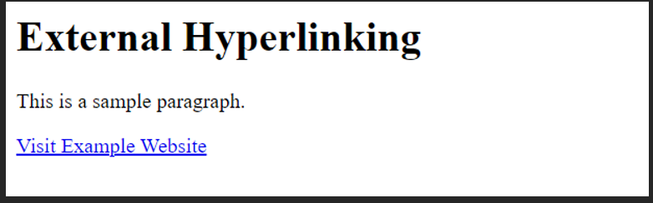

**Q24. Write code to show External CSS with HTML code.**

<html>

<head>

<title>External CSS</title>

<link rel="stylesheet" href="styles.css">

</head>

<body>

<h1>Hello,World!</h1>

<p>This is a paragraph.</p>

</body>

</html>



**Q25. Write code to show Internal CSS with HTML code.**

<html>

<head>

<style>

body {

font-family: Arial;

background-color:blue;

}

h1 {

color:green;

text-align:center;

}

p {

color: red;

font-size: 18px;

}

</style>

</head>

<h1>Hello World!</h1>

<p>This is a paragraph styled with internal CSS to show styled sheet.</p>

</body>

</html>



**Q26. Write code to show Inline CSS with HTML code?**

<html>

<body>

<h1 style="color: blue; text-align: left;">Hello World!</h1>

<p style="color: red; font-size: 15px;">This is a paragraph styled with inline

CSS. </p>

</body>

</html>



**Q27. Write a program to add two numbers using form in JavaScript.**

<html>

<head>

<title>Add Two Numbers</title>

</head>

<body>

<h1>Add Two Numbers</h1>

<form id="myForm">

<label for="num1">Number 1:</label>

<input type="number" id="num1" name="num1"><br><br>

<label for="num2">Number 2:</label>

<input type="number" id="num2" name="num2"><br><br>

<button type="button" onclick="addNumbers()">Add</button>

</form>

<p id="result"></p>

<script>

function addNumbers() {

// Get the values from the input fields

let num1 = parseFloat(document.getElementById("num1").value);

let num2 = parseFloat(document.getElementById("num2").value);

// Add the numbers

let sum = num1 + num2;

document.getElementById("result").innerHTML = "The sum is: " + sum;

}

</script>

</body>

</html>

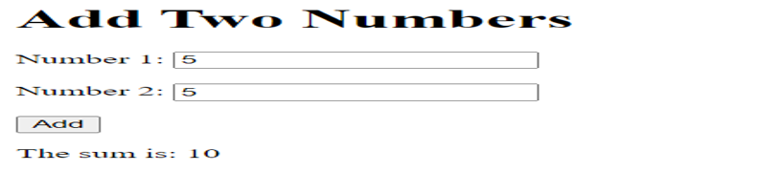

28. Write a program in JavaScript to swap two images using on mouseover event.

<html>

<head>

<title>Image Swap on Mouseover</title>

<style>

img {

width: 200px;

height: 200px;

}

</style>

</head>

<body>

<img id="image1" src="image1.png" onmouseover="swapImages()" onmouseout="swapBack()">

<img id="image2" src="image2.png" style="display: none;">

<script>

function swapImages() {

document.getElementById("image1").style.display = "none";

document.getElementById("image2").style.display = "block";

}

function swapBack() {

document.getElementById("image1").style.display = "block";

document.getElementById("image2").style.display = "none";

}

</script>

</body>

</html>

29. Write a simple JavaScript program to sort an array?

<html>

<head>

<title>Sorting Array</title>

</head>

<body>

<p id="result"></p>

<script>

function sortArray() {

const numbers = [5, 2, 9, 1, 5, 6];

numbers.sort((a, b) => a - b);

document.getElementById("result").textContent = "Sorted array: " + numbers.join(", ");

} sortArray();

</script>

</body>

</html>



**Q30: Write a JavaScript program to take as input three numbers from the user. Find the minimum and maximum of the three numbers. Print the following output in BOLD in the following format:**

<html>

<head>

<title>Find Minimum and Maximum</title>

</head>

<body>

<input type="number" id="num1" placeholder="Enter first number">

<input type="number" id="num2" placeholder="Enter second number">

<input type="number" id="num3" placeholder="Enter third number">

<button onclick="findMinMax()">Find Min/Max</button>

<p id="result"></p>

<script>

function findMinMax() {

const num1 = parseFloat(document.getElementById("num1").value);

const num2 = parseFloat(document.getElementById("num2").value);

const num3 = parseFloat(document.getElementById("num3").value);

const min = Math.min(num1, num2, num3);

const max = Math.max(num1, num2, num3);

document.getElementById("result").innerHTML = `

<b>Minimum number:</b> ${min}<br>

<b>Maximum number:</b> ${max}

`;

}

</script>

</body>

</html>

